**CHAPTER 1: INTRODUCTION**

* 1. **INTRODUCTION**

Manual system used in TDT Shop has variety of problems. Customers facing the same problems regularly. It’s so hard because customer have to wait for a long time to print their documents. Admin get confuse because there is no proper system to identify the customer’s documents.

Based on these problem, we are creating a project entitled “TDT Online Printing System” for make ease to the customer and Admin. This system is an extensive network of customer and Admin in sending and receiving messages. Besides, this system can also increase a person's income in the economic field. During booking, all customer prefer to do their research online, it's also a system that allow customer to finish their work quickly.

* 1. **STUDY BACKGROUND**

"Online Printing System" is a strategic interest in the business and it has been used so widely. The system is useful if the information is accurate, updated and easily available."Online Printing System" refers to a system that prints documents to achieve a certain function.

"Online Printing System" is important because it can give an advantage to customers who have used it. Thus, "Online Printing System" manual is no longer commensurate with the current period. In addition, the existing system manually forcing customer to take a relatively short time to get a document. Therefore, this system was developed to help reduce our workload and management.

* 1. **PROBLEM STATEMENT**

The downside to use a manual system management is clearly a big impact in the excellent performance management aspects of time management. One of it is less efficient for the user information search, payment and file search.

Next, the problems faced by customer is a problem when printing. Customers will save the document they want to print in pendrive and give it to the owner of the printing shop does not give any instructions. Sometimes these drives will be created problems such as viruses, hidden files, and there are many files with the same name.

Finally, the difficulty each time to manually check the records of customers who still do not make payments on time.

* 1. **OBJECTIVES**

In order to develop online printing system, the objective of this system is:

1) To use an online system which reduces users time for completion of printing.

2) To send orders by online and also user can get payment information.

3) To track status such as pending,printing and finish to pick up by online.

**1.5 SCOPE OF STUDY**

**Organization / Place**

"TDT SHOP".

**System**

"Online Printing System" is a computerized system operated and is online. The scope of this system is admin and customer. Admin can add new staff to the system, can view the list of new users and also can check the order list send by the user to print. Whereas, user can sign up this system to login. Once they login, they can attach their document or file in the system to print. User also can view the status of their printing process to know the current process. Once done printing, admin will update the process of printing status so that, the user can come to the shop to get their document or file and also their receipt.

**Consumer**

i) Customers

Customers can sign up as a new user to the system. Then, customer can login and attach their documents or file to print. They also can check the status of their printing process.

ii) Admin

Admin can add new staff into the system. Admin also can view the list of new users of the system. Besides that, admin can view the order list send by the customers. Admin can print the documents or file once received order. Admin can update the status of printing process. Once done printing admin will print the receipt.

* 1. **INTEREST**

    This system can be used to replace the manual system. This project will benefit users because they are able to manage the system easily without the use of any material. Module be built is an added module records, view records, delete records, edit records and statistic records.

Management process can be centralized, the process of sending status and store files that can be performed by the owner. This system will save time and energy. Information in the system will be stored safely and securely. Only admin can use this system to access because it requires a unique username and password.

* 1. **SUMMARY**

The aim of this project is to help "TDT SHOP" to establish and develop a system that can simplify management of the shop. This chapter is about the construction of the initial phase of the system that will explain the background of the project identification and problem statement for the project. This system has the advantage of previous manual system of objective aspects of this system, the target consumer, the benefits of this system and the expected results of this project. The statement describes the problems related to the issue of why the system is developed.

**CHAPTER 2 : LITERATURE REVIEW**

**2.1 INTRODUCTION**

The literature review is a process of gathering information and data about the projects that have been developed in the form of a diagram on which the system will be developed. In addition, it also refers to the activities of collecting information and research on topics that are particularly relevant aspect identify problems and measures to resolve them. Apart from that, it also refers to the difference between the system we use the "TDT Online Printing System" with other systems. For example. “ Copytech Printing System" ,”Print UI.Com” and **“**PRINT SHOP Printing system**”**. There are various ways that can be used in the process of collecting data such as making comparisons between systems that are available.

**2.2 CONCEPT/THEORY**

"TDT Online Printing System" is a strategic interest in the business and it has been used so widely. The system is useful if the information is accurate, updated and easily available. "Online Printing System" refers to a system that prints documents to achieve a certain function.

"Online Printing System" is important because it can give an advantage to customers who have used it. Thus, "Online Printing System" manual is no longer commensurate with the current period. In addition, the existing system manually forcing customers to take a relatively short time to get a document. Therefore, this system was developed to help reduce our workload and management.

**2.3 PREVIOUS RESEARCH**

|  |  |  |
| --- | --- | --- |
| **Case study 1** | **Case study 2** | **Case study 3** |
| **“Copytech printing system”** | **“Print UI.Com”** | **“PRINT SHOP Printing system”** |
| Cannot register | Can register | Cannot register |
| Can upload file contain picture only | Can upload file such as important documents and also pictures | Cannot upload file |
| Cannot check full payment in printed form | Can check full payment in colour or black and white printed form | Can check full payment |

**2.4 CONCLUSION**

From the results of our studies have been conducted on all three systems, including systems that we will develop for "TDT Online Printing System" available, each system has a different role. Therefore, we will develop a better system than the existing system. Our system will function more efficiently to keep records of users, to track the status and also to create payment receipt. We develop this system so that it will indirectly easier to manage because it is different from the existing system.

**CHAPTER 3:RESEARCH METHODOLOGY**

**3.1 INTRODUCTION**

Chapter 3, focuses on matters connected with the activities such as the selection method used during the development of this major project .Aspect of the system to the things to be considered when making an inquiry in this project.

**3.2 RESEARCH DESIGN**

This study will be conducted using quantitative methods.

**3.3 DATA COLLECTION METHOD**

Selected quantitative methods for data collection was conducted using questionnaires. Questionnaires distributed to respondents in person.Data collection period will last for 1 week.

**3.4 RESEARCH INSTRUMENTS**

**3.4.1 SOFTWARE REQUIREMENTS**

This software is a set of instructions that implement measures to control the activities of care and support system. Choosing software online as compared to the elements or functions that will be produced during the system development process. Here, the software used to improve the process "Online Printing System": -

i) XAMPP Apache Web Server

ii) Notepad ++

iii) PHPMYADMIN

i) XAMPP Apache Web Server

"XAMPP Apache Web Server" software is required in systems development. "Apache" is a web server that creates a page and can be accessed easily and quickly from a personal website.

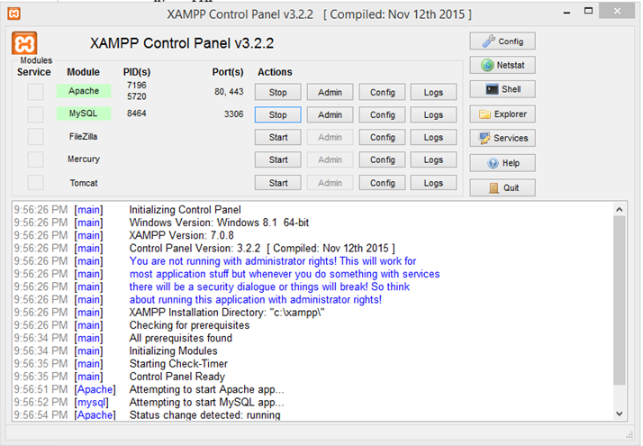

ii) Notepad ++

"Notepad ++" is a source code editor and a "window" that can be used to create a kind of coding system.

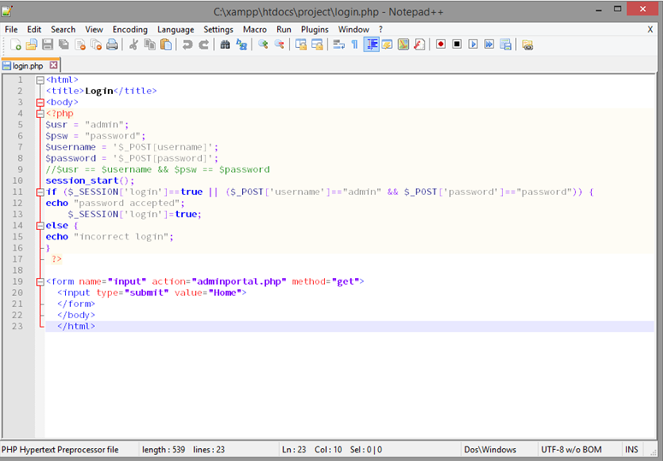

iii) PHPMYADMIN

"PhpMyAdmin" is 'free software' written in 'php' programming that is used to handle the administration "MYSQL" over the World Area Network ( "World Wide Web"). Thus, "PhpMyAdmin" supports various operations, including managing databases, tables, fields ( "fields"), relations ( "relations"), and a web server that issued the index.

**3.4.2 HARDWARE REQUIREMENTS**

In developing the system hardware "required" for the development of the specifications easier to load software used and the necessary data here is easy. Here, the hardware used to improve the process "Online Printing System".

|  |  |
| --- | --- |
| Hardware | Requirements |
| 1. Personal Computer | Intel Inside   * “Acer” * “2 GB DDR3 L memory” * “500 GB HDD” * “Intel HD Graphics” * “Microsoft windows 8” |
| 1. Pendrive | * “Kingstone” * “8 GB” |

**3.5 DATA ANALYSIS METHODS**

The process of evaluating data using analytical and logical reasoning to examine each component of the data provided. This form of analysis is just one of the many steps that must be completed when conducting a research experiment. Data from various sources is gathered, reviewed, and then analysed to form some sort of finding or conclusion. There are a variety of specific data analysis method, some of which include data mining, text analytics, business intelligence and data visualizations.

**3.6 SUMMARY OF CHAPTER**

In this chapter, we can get a lot of experience of how to analyze the system, designing data collection methods, develop a system from scratch, implement the system in a real life so that we can know the system. Finally, in the assessment phase we can benefit from the system when using this system.

**CHAPTER 4:THE FINDINGS**

**4.1 CHAPTER INTRODUCTION**

Introduction of this chapter aims to bring the reader into thinking the picture based on the objectives of the study and research questions. This chapter will explain the whole study would be carried out. Things are detailed in this section are as response rates, the demographic profile of the respondents, variables, parameters and findings.

**INTERVIEW**

|  |  |
| --- | --- |
| Interviewee : Mr.Kaasiviswanathan | Interviewer: Thamarai Selvi Kobalan |
| Location : TDT Shop,Jalan Bujang 06000, Jitra Kedah. | Appointment date:  Start time: 2.00 pm  End Time: 4.00 pm |
| Objective:   1. To simplified communication between customer and admin. 2. To send orders by online. 3. To track status by online. |  |
| Agenda:  I am Thamarai Selvi Kobalan , student from Polimas. I am studying Diploma in Information Technology, Semester 5.I am doing a final year project entitled “Online Printing System”. This system is about |  |
| Question: | Note: |
| Question 1: How do you receive printing orders from your customer? |  |
| Question 2: Do you have any web based system to record printing orders from your customer? |  |
| Question 3: Explain about the flow of your management? |  |
| Question 4: What is your opinion on using a web based system? |  |
| Question 5: Can I have the sample of printing orders from your customer for my references? |  |
| Unresolved issue/ topic not cover: | |

**QUESTIONNAIRE**

Direction: Check the box that corresponds to your answer.Use the legend as your guide.

**LEGEND: 5-Excellent 4-Very Good 3-Good 2-Fair 1-Poor**

|  |  |  |  |  |  |
| --- | --- | --- | --- | --- | --- |
| **DESIGN** | **5** | **4** | **3** | **2** | **1** |
| 1.1 The design of the system and website is appealing to the eyes of the user |  |  |  |  |  |
| 1 .2 The graphics of the system is attractive |  |  |  |  |  |
| **PERFORMANCE** |  |  |  |  |  |
| 2.1 The system has the capability to send their document |  |  |  |  |  |
| 2.2 The system is capable of receiving status messages |  |  |  |  |  |
| **MAINTANABILITY** |  |  |  |  |  |
| 3.1 The system can easily correct the faults |  |  |  |  |  |
| 3.2 The system can adapt to the system environment |  |  |  |  |  |
| **SECURITY** |  |  |  |  |  |
| 4.1 In online system the document of the user secured |  |  |  |  |  |
| 4.2 The documents cannot be edited if the user submitted already |  |  |  |  |  |

**4.2 DESIGN REVIEW**

The study design is a blueprint that shows in detail how the study was conducted. It also serves as a guide to help researchers in the process of collecting, analyzing and interpreting the results of the research conducted. Research design also serve as a model to enable researchers to make inferences regarding the variables studied.

This research is a descriptive study that aims to identify and easy to send a document or file online. Survey using questionnaire was conducted to obtain information from respondents.

**USER INTERFACE**

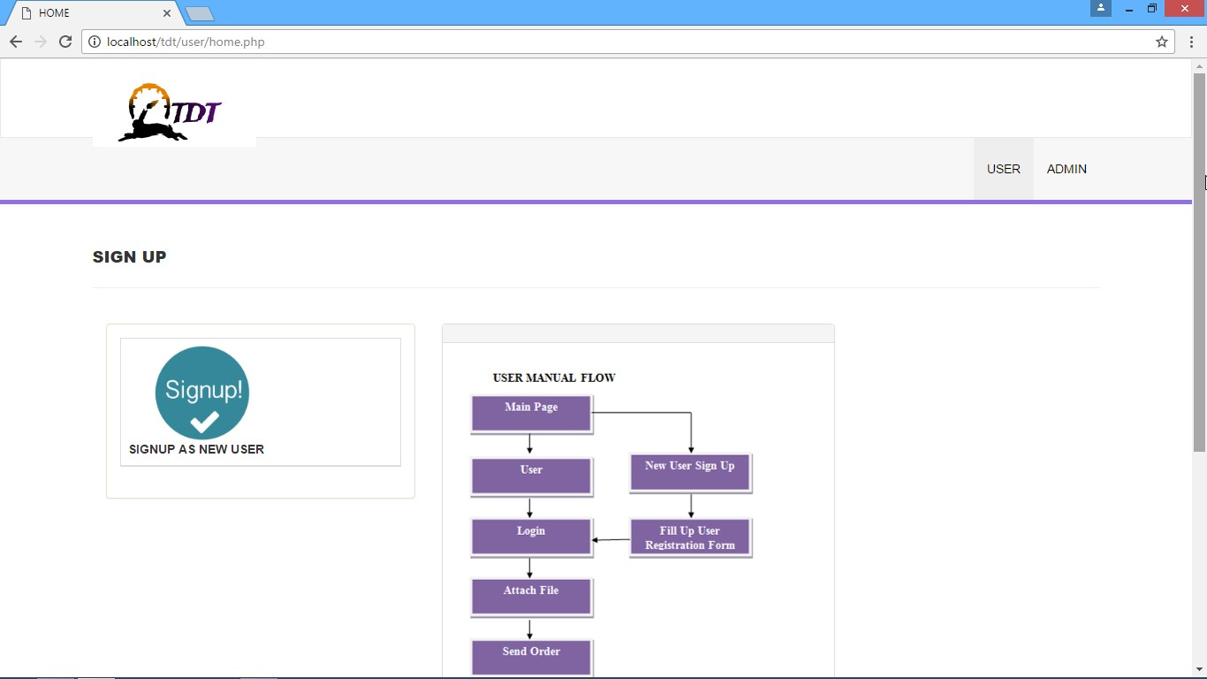

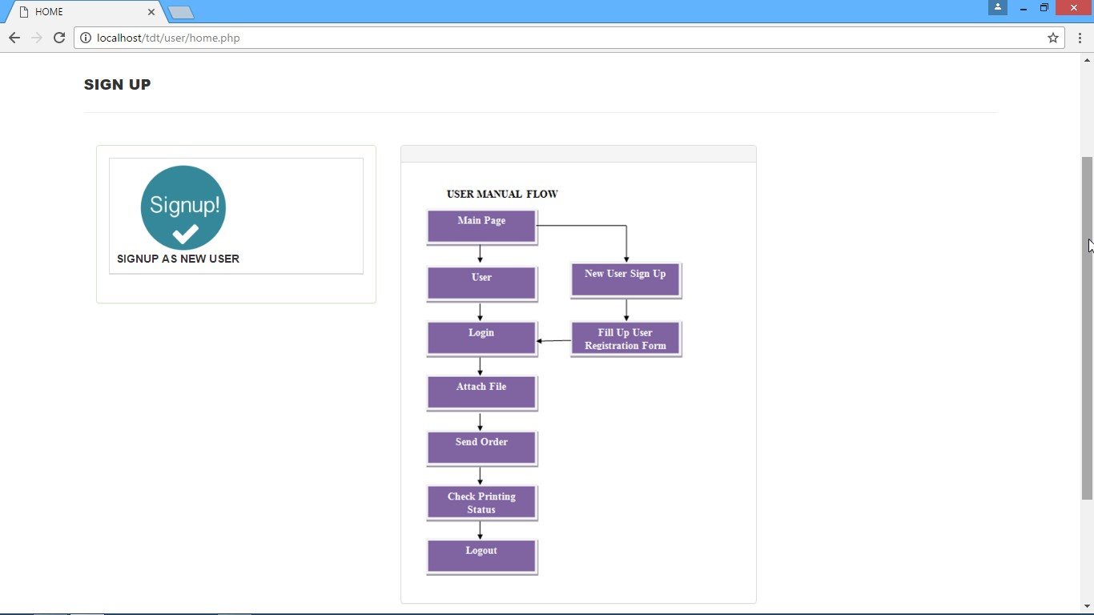

Figure 4.1 shows the front page of "Online Printing System" to signup new user, login for user and admin.

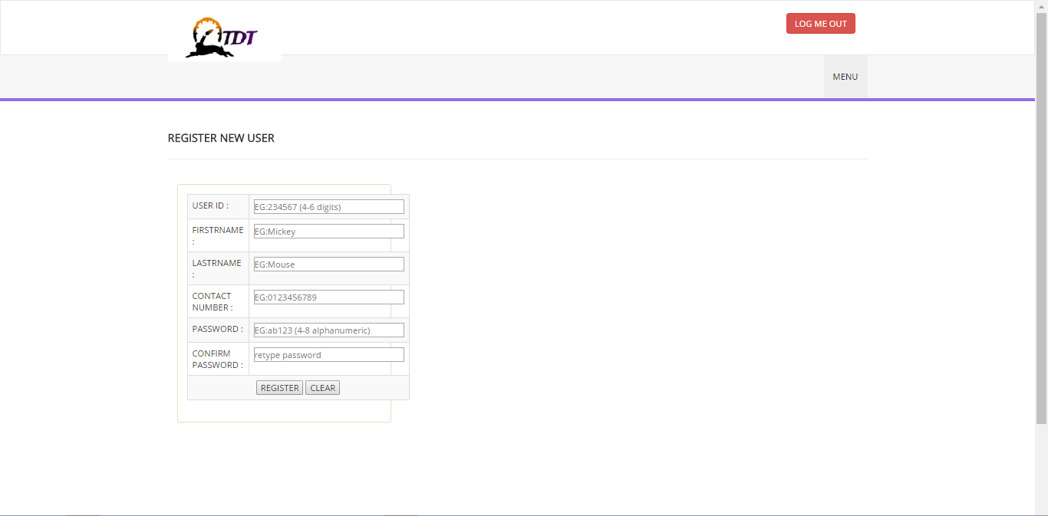

Figure 4.2 shows the registration page for user.

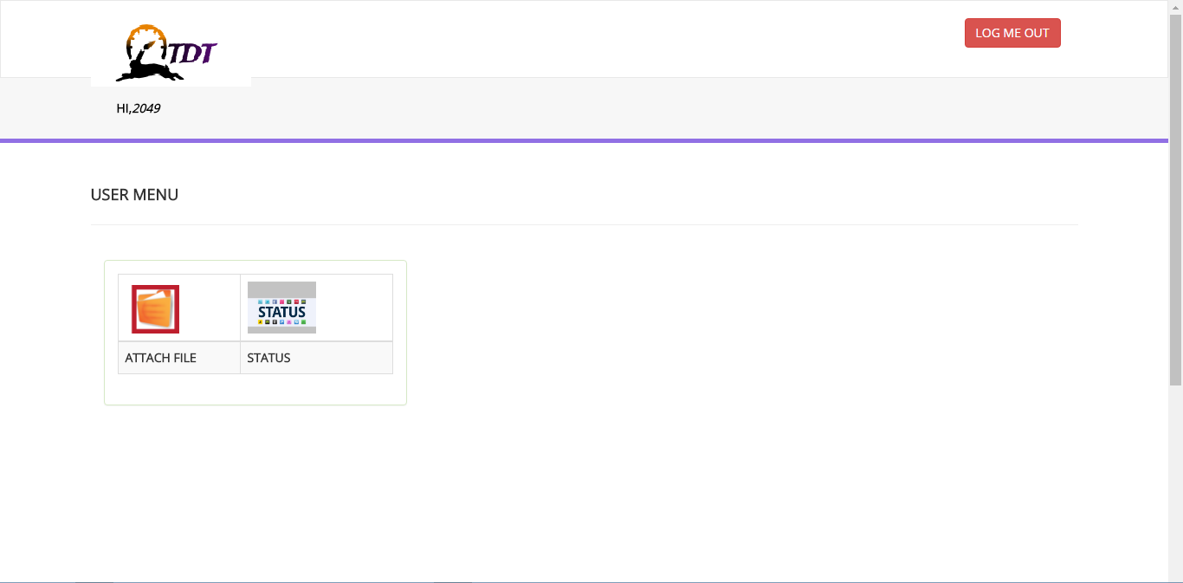

Figure 4.3 shows that user can attach files and view their printing status in this interface.

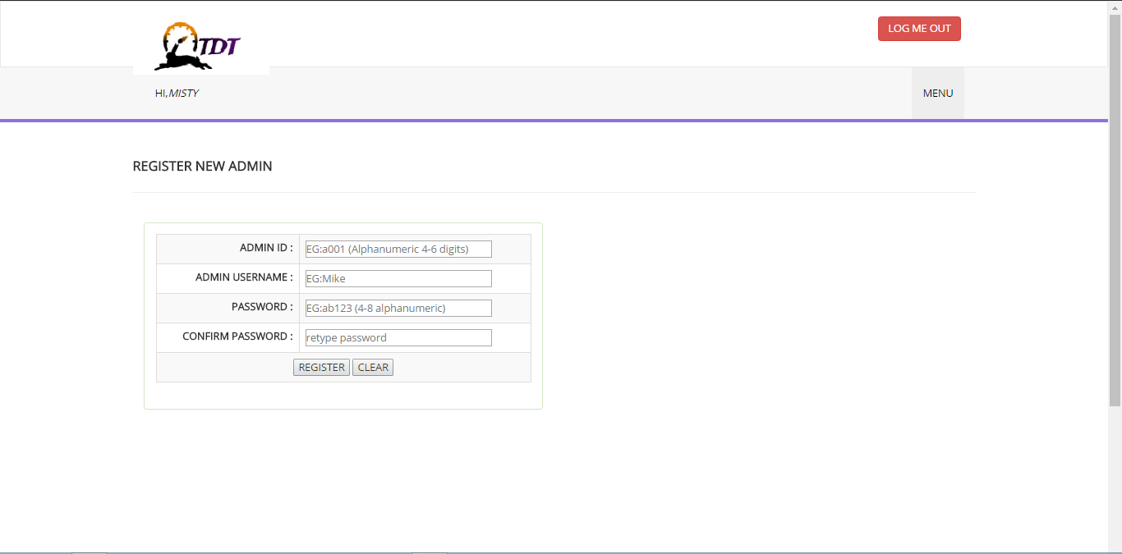

Figure 4.4 shows the registration page for admin.

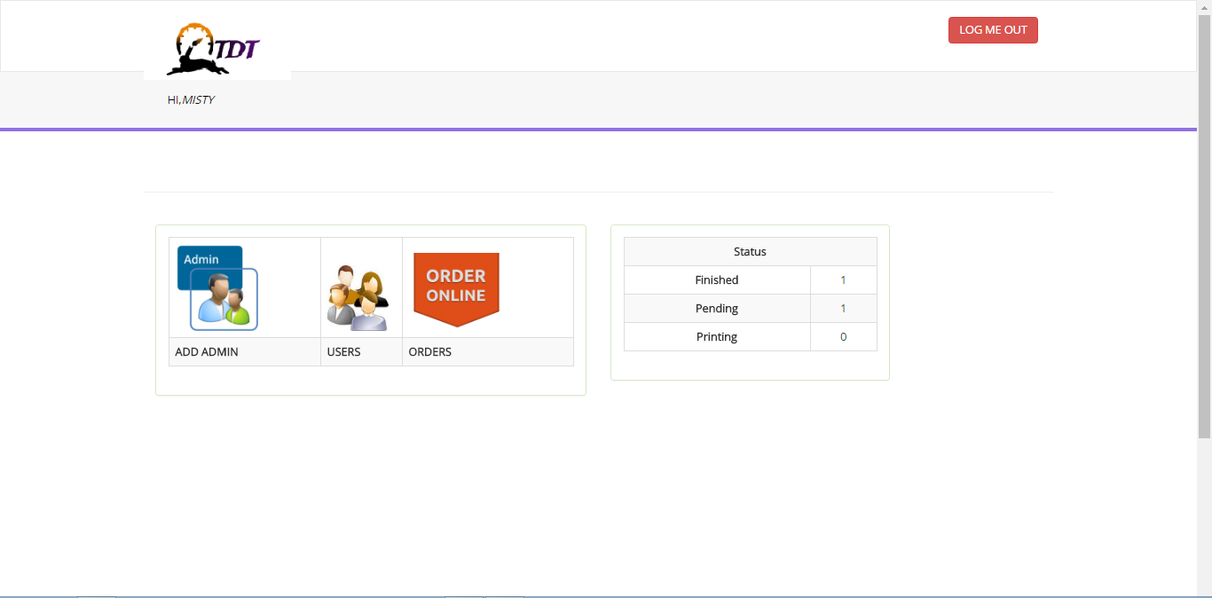

Figure 4.5 shows that admin can view the list of new users, can add new staff and check the list of printing orders in this interface.

**4.3 FINDINGS**  
**4.3.1 RELATED ENTITIES**

Have to

User registration

login

record

order

status

Payment info

Figure 4.3.1 shows the related entities of “Online Printing System”

**4.3.2 DATA FLOW**

Data Flow Diagram (Data-Flow Diagram) was introduced and developed by "Gane and Sarson" in 1979 to develop structural analysis and design. Data Flow Diagram shows the flow of data from external entities to the Data Flow system. Diagram shows how to move data from one process to another. Based on Data Flow Diagram developed by Gane and Sarson, this figure has four symbols, namely:

* A rectangle shows the external entity, which is the source or destination of the data.
* Rounded rectangle shows the process, the input and output
* The arrows indicate the flow of data
* Open rectangle shows the data storage such as a database or XML

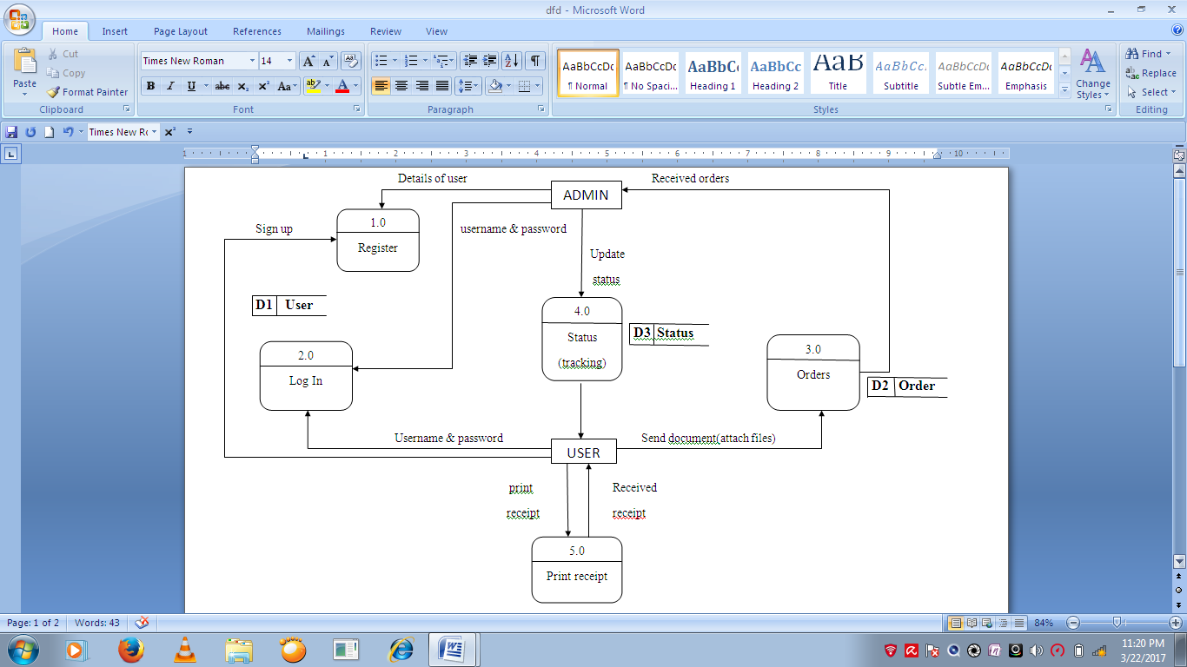

Figure 4.3.2 shows the data flow of “Online Printing System”

**4.3.3 FLOWCHART**

Is one of the earliest tools used for documenting process and help to develop a system to guide the flow chart.

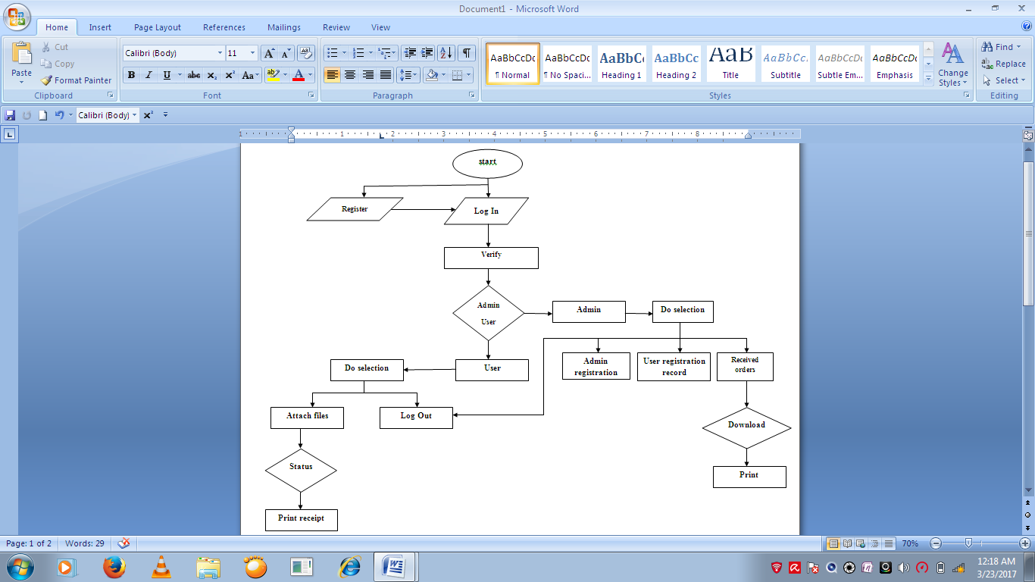

Figure 4.3.3 shows the flowchart of “Online Printing System”

**4.3.4 CONTACT DIAGRAM**

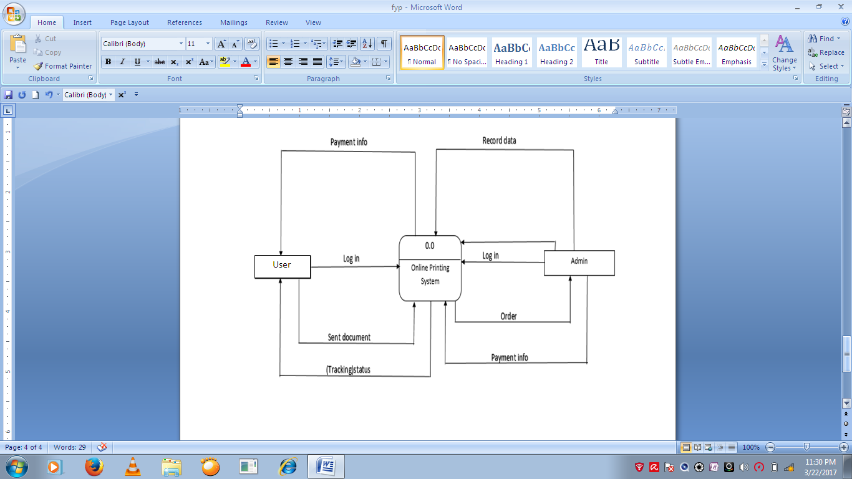

Figure 4.3.4 shows the contact diagram of “Online Printing System”

**4.4 CONCLUSION**

In this chapter, we can get a lot of experience of how to analyze the system, designing the interface and database structure, develop a system from scratch, implement the system in a real life so that we can know the system. Finally, in the assessment phase we can get benefit from the system when using this system.

**CHAPTER 5: DEVELOPMENT AND TESTING**

**5.1 INTRODUCTION**

The results of the analysis and design phase will continue in the next phase of testing. At this phase, the focus will be directed to the testing system. In the test, the system will be tested in terms of functionality and user acceptance of the system developed. From the results we found, we can make an assessment of whether the results obtained it will achieve its objective or not.

.

**5.2 DISCUSSION**

The test system is a very important step in the construction of a system application. The test system is intended to ensure that the system developed independently of any errors and mistakes either in terms of language or logic. Testing to determine the system is free from any errors of language or logic errors made during the time when coding a program-code system implemented. Wrong code direction will continue to be corrected and the process of testing this code will continue to be implemented until the completion of this system is developed. In addition, system testing is done to ensure that the system developed to meet the objectives, scope and needs of the users. In the development of this system, the test methods to be used which is testing the usability, functionality and user acceptance of the system.

**5.3 TESTING FUNCTION**

The test is intended to determine the function of the system is developed to meet the quality set and also comply with all the requirements set by users of the system will involve that. Testing functions been developed and is available in the system. The results of these tests will determine whether it meets the requirements set.

**5.3.1 FIRST PAGE FUNCTION**

In this test, the cover page will be used by two users, the owner and the user. This is to separate the owners and users log into the system.



Figure 5.3.1 First Page Interface

**5.3.2 REGISTRATION FUNCTION**

In this test users should register their personal infomation. Information must fill in the correct order to avoid errors during the process of registration. After fill all the information, the user must click on the button "register" so that the data can be stored in the database properly.



Figure 5.3.2 New User Registration Form Interface

**5.3.3 USER LOG IN FUNCTION**

In this test, the user will log in with the username and password that has been registered. This is to ensure that a particular user will only be given specific functions only. Testing initiated by the user choose to log into the system and enter the username and password that has been registered. If a wrong password or wrong username is entered, the user cannot login.

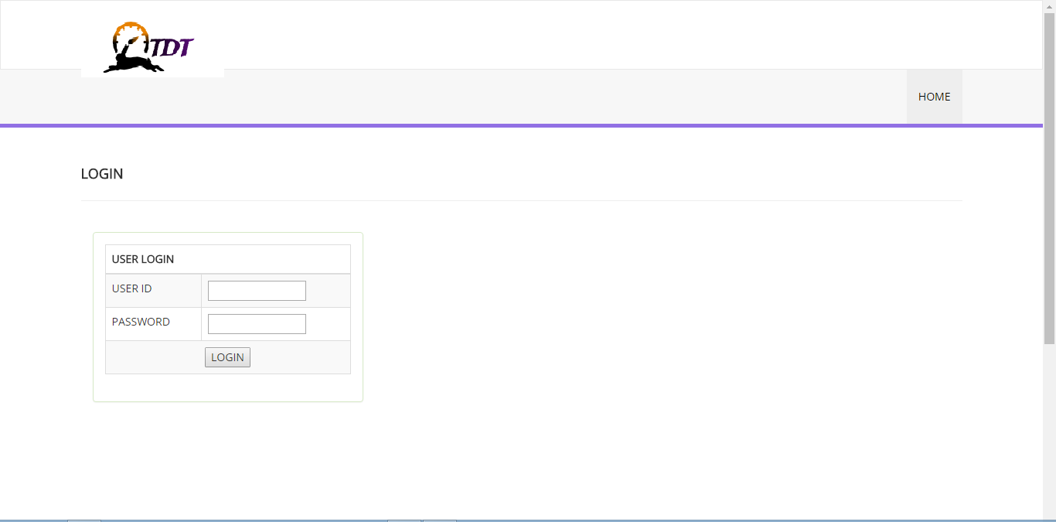

Figure 5.3.3 User Log In Interface

**5.3.4 USER MENU PAGE FUNCTION**

After logging into the system by using the user’s username and password will display the user interface. User can choose to upload files or documents for admin by clicking the upload button. User can also check their order’s status by clicking the check status button.



Figure 5.3.4 User Menu Page Interface

**5.3.5 UPLOAD FILE FUNCTION**

In this test, users upload their files correctly to admin. Details must be filled properly to avoid errors during printing. Once completed, the user must click on the button "send" to send the file to the owner.

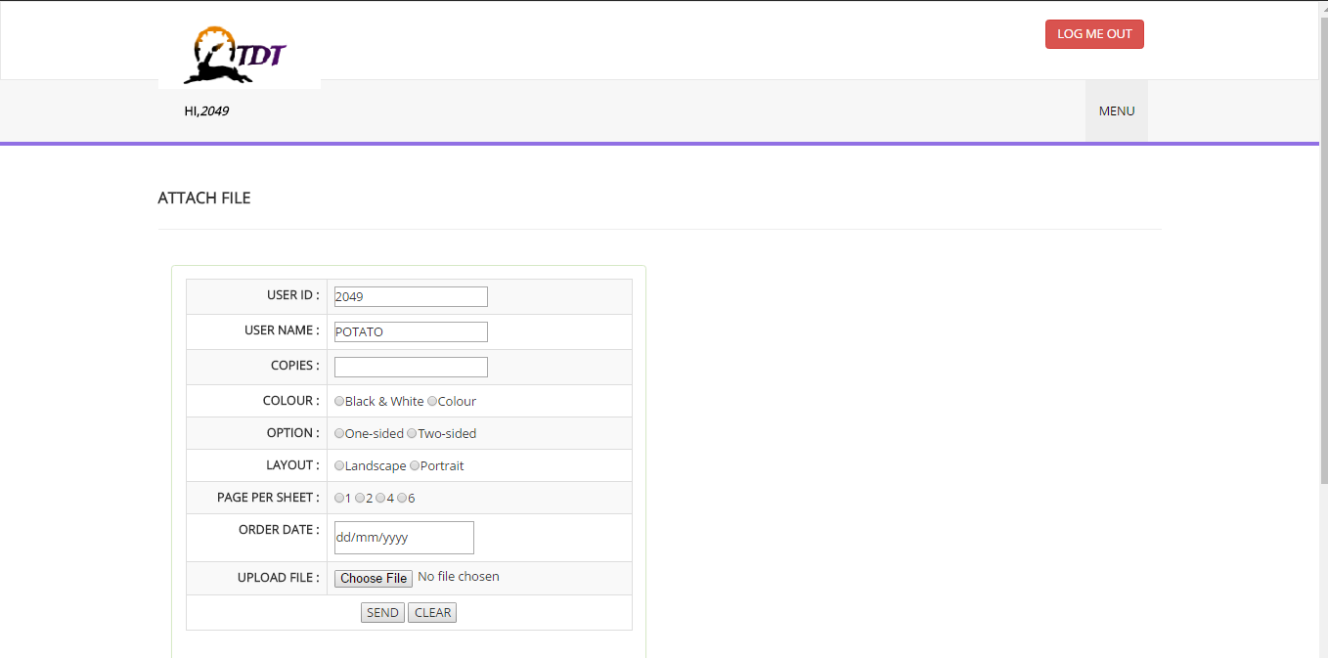

Figure 5.3.5 Upload File Interface

**5.3.6 CHECK STATUS FUNCTION**

In this test, users can check the status of their order in this interface. User’s status will show in a table. The status will be shown as ‘Finished & Pick Up’ if their order is finished and shown as ‘Pending’ if their order is still on working.

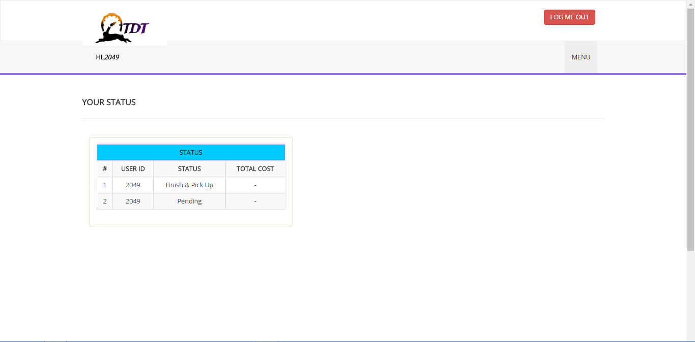

Figure 5.3.6 Check Status Interface

**5.3.7 ADMIN LOG IN FUNCTION**

In this test, admin will sign in using their username and password has been set. This is to ensure that the admin will just show that certain specific functions only. If the admin enters a wrong username or password , the admin cannot login.

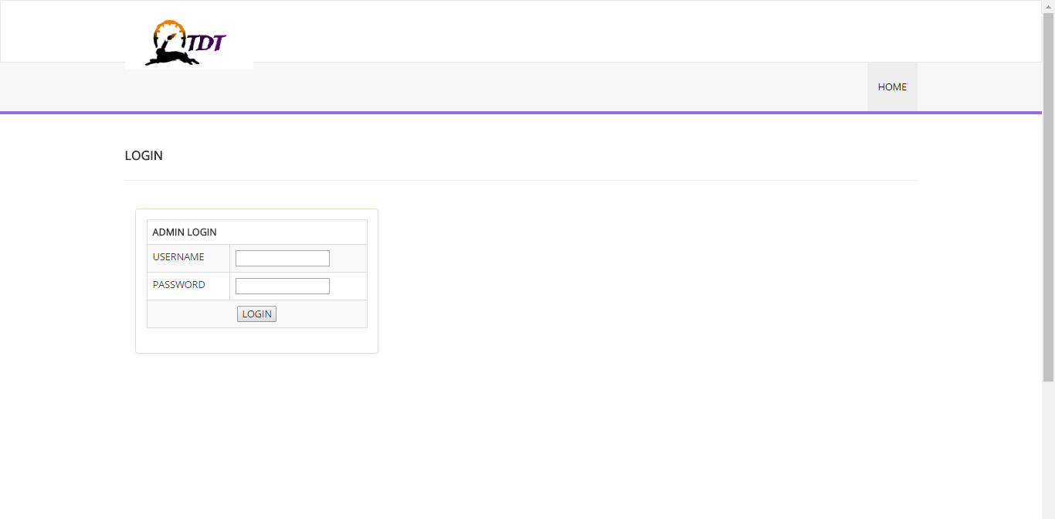

Figure 5.3.7 Admin Log In Interface

**5.3.8 ADMIN MENU PAGE**

After logging into the system by using username and password will display the admin interfaces. This diagram shows the admin can select some functions such as check user list, check order and view total status of order.



Figure 5.3.8 Admin Menu Interface

**5.3.9 USERS REGISTERED INFORMATION**

In this test, the admin can obtain details of users. Admin can view and know how many users are registered and using the system.

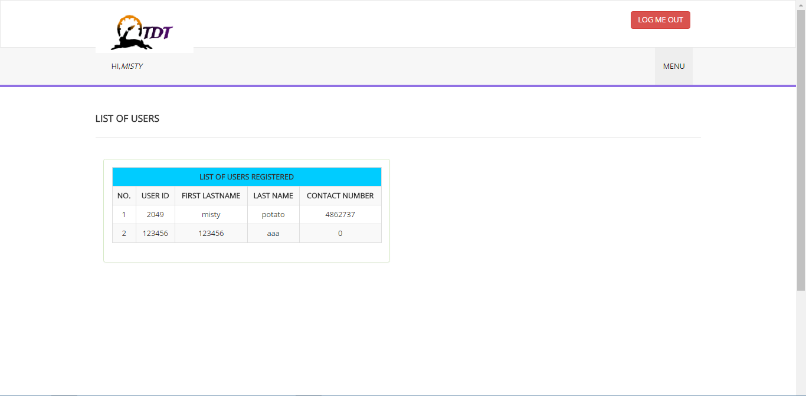

Figure 5.3.9 Users Registered Information Interface

**5.3.10 RECEIVE ORDER FUNCTION**

In this test, the admin can view order from the user. Admin can click "print" to print files that have been sent by the user and click "reply" to make a receipt to the user.

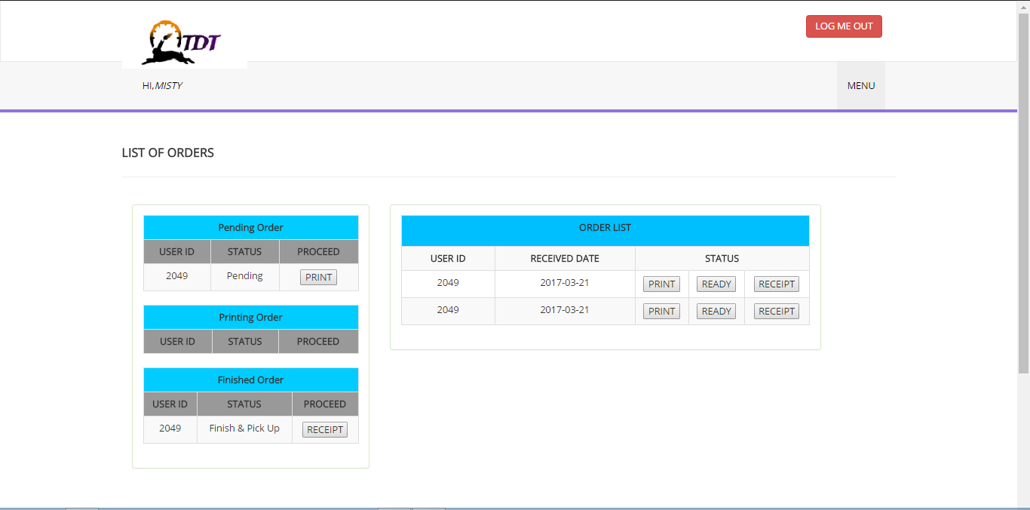

Figure 5.3.10 Receive Order Interface

**5.3.11 RECEIPT FUNCTION**

In this test, admin can make a receipt for users. The price will be calculated depend on the information of that user.

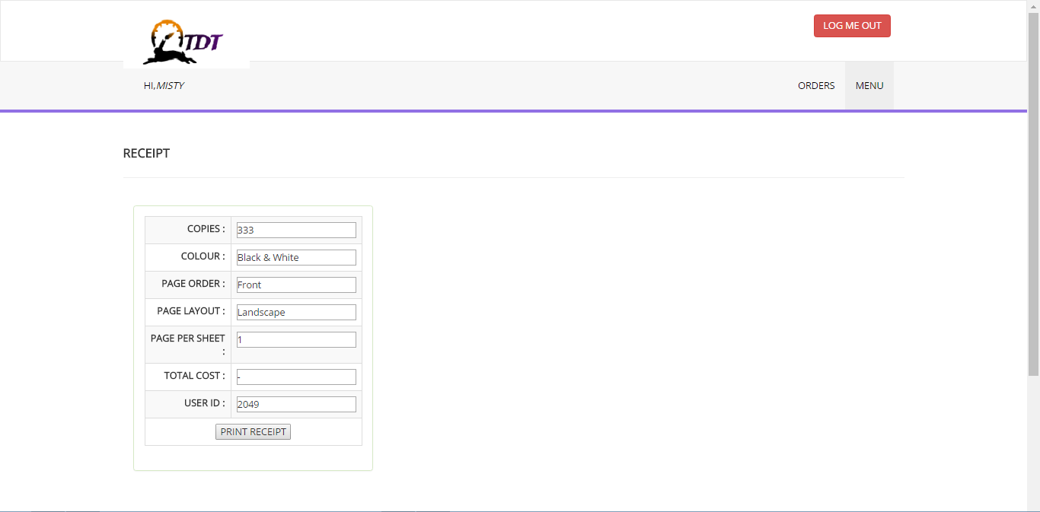

Figure 5.3.11 Receipt Interface

**5.4 CONCLUSION**

In this chapter, we can get a lot of experience of how to analyze the system and testing the actual system so that we can know the system. Finally, in the assessment phase we got advantage from the system when using it.

**CHAPTER 6: DISCUSSION AND CONCLUSION**

**6.1 INTRODUCTION**

This chapter describes the results of the discussions and conclusions of the various information that has been obtained from projects that have been completed and carried out in the chapters before.

**6.2 BACKUP AND SUMMARY**

The sequence of the weaknesses of the existing system now, various measures have been taken and will be taken to develop a system that can satisfy the user. In this era of information technology, problems such as the recorded data manually should not be created because it would delay the work should be completed quickly until a system has been developed to address this issue systems named "ONLINE PRINTING SYSTEM" .System it also meets the criteria as a system that is able to run in a different site or the environment because it uses a programming language and system specifications of the latest to build it. With this system, users are also expected to be able to overcome their problems, especially the problem of wasted time. The system can launch and accelerate the process of seeking and obtaining the necessary information. It is also used for maintenance of the database stored data has limitations of its own. The conclusion that can be made is, there are many elements of the improvements that can be incorporated into this system. These improvements will complement the existing manual systems and can be used by many parties to control the printing process on-line.

**REFERENCES**

Refer from the website

1. Helping student to creat and register using php.Retrieved from

<http://creativealive.com/basic-registration-form-php-mysql-database-connectivity/>

1. PHP login script tutorial,tutorial Display to incorporate login to join the new database system,Retrieved from <http://www.phpeasystep.com/phptu/5.html>
2. W3School, pages give examples and traning to users,here focus to relating to database system,Retrieved from <http://www.w3shcools.com>
3. How to upload file using a code path ih php and mysql insert,Retrieved from

<http://stakckoverflow.com/how-to-upload-file-php-and-insert-mysql>

1. Literature Review , Retrieved from

<https://copytech-print.mit.edu/>

http://printui.com/hosted-indesign-web-to-print-service.php?gclid=CMq0r-r29tICFdIXaAodBdsLEw